System and Software Architecture Description (SSAD)

Mission Science Information and Data Management System 2.0

Team number 2

Nakarin Kamkheaw : Project Manager, Feasibility Analysis, Builder

Abhijeet Singh : Lifecycle Planner, Tester

Yuling Lan : Operational Concept Engineer, Requirement Engineer, Prototyper

Robert Morse : IIV&V, Shaper, System Architect

12/5/12

Version History
Date | Author | Version | Changes made | Rationale
10/14/12 | RM | 1.0 | - Completed sections 1, 2.1.1-2.1.3 | - For Core FC Package
10/22/12 | RM | 1.1 | - Revised to use NDI Template | - For Draft FC Package
11/1/12 | RM | 1.2 | - Resolved defects reported from IIV&V  - Resolved defects reported from TA review | - Update for inter-document consistency
11/5/12 | RM | 2.0 | - Added NDI interoperability section | - For DC package
11/14/12 | RM | 2.1 | - Replaced references to “Administrator” with “Coordinator” for consistency, including System Context Diagram, Process Diagram, and System Structure Diagram. | - For IIV&V Review Feedback
12/5/12 | RM | 3.0 | - Tables do not break over pages  - Header and footer version correct throughout.  - Replaced System Context Diagram with correction to remove Undergraduate Student. Matching update to corresponding table.  - Replaced Artifacts Diagram with 2 separate diagrams for accuracy and clarity.  - Corrected errors in use cases.  - Corrections to writing style and grammar. | - Response to IIV&V  - Feedback from TA

Table of Contents
System and Software Architecture Description (SSAD) i
Version History ii
Table of Contents iii
Table of Tables iv
Table of Figures v
1. Introduction 1
1.1 Purpose of the SSAD 1
1.2 Status of the SSAD 1
2. System Analysis 3
2.1 System Analysis Overview 3
2.1.1 System Context 3
2.1.2 Artifacts & Information 5
2.1.3 Behavior 7
2.1.3.1 System User Behaviors 9
2.1.3.1.1 Manage student information 9
2.1.3.1.2 Input sign-in sheet 10
2.1.3.1.3 Manage inventory 12
2.1.3.2 Graduate Student Behaviors 13
2.1.3.2.1 Retrieve lesson plan 13
2.1.3.3 Administrator Behaviors 14
2.1.3.3.1 Manage projects 14
2.1.3.3.2 View usage logs 15
2.1.3.3.3 Generate reports 15
3. NDI/NCS Interoperability Analysis 17
3.1 Introduction 17
3.1.1 COTS / GOTS / ROTS / Open Source / NCS 17
3.1.2 Connectors 17
3.1.3 Legacy System 17
3.2 System Structure 17
3.3 Evaluation Summary 18

Table of Tables
Table 1: Actors Summary 4
Table 2: Artifacts and Information Summary 6
Table 3: Process Description 9
Table 4: Typical Course of Action 10
Table 5: Alternate Course of Action 10
Table 6: Exceptional Course of Action 10
Table 7: Process Description 11
Table 8: Typical Course of Action 11
Table 9: Alternate Course of Action 11
Table 10: Process Description 12
Table 11: Typical Course of Action 12
Table 12: Alternate Course of Action 12
Table 13: Process Description 13
Table 14: Typical Course of Action 13
Table 15: Alternate Course of Action 13
Table 16: Process Description 14
Table 17: Typical Course of Action 14
Table 18: Alternate Course of Action 14
Table 19: Process Description 15
Table 20: Typical Course of Action 15
Table 21: Process Description 15
Table 22: Typical Course of Action 16
Table 23: Alternate Course of Action 16
Table 7: NDI Products Listing 17
Table 8: NDI Evaluation 18

Table of Figures
Figure 1: System Context Diagram 3
Figure 2: Artifacts and Information Diagram 5
Figure 3: Process Diagram 9

Introduction

Purpose of the SSAD
The SSAD serves to document the architecture, and more specifically, the object-oriented analysis and design of the Mission Science 2.0 system. The SSAD is to be used by the builder in building the prescribed system. The system should remain faithful to the prescribed architecture of the SSAD, or the SSAD should be updated to match the latent architecture. The SSAD is used as reference by the maintainers once the system is delivered.

Status of the SSAD
The SSAD has also been revised to more accurately document the architecture of the system as more information has been discovered. The Artifact diagrams are much more accurate, and directly from the database system with two major views: Student and Project. Grammar has been revised. Use cases are clearer and more correct. General formatting is easier to read. The references to Administrator have been corrected to Coordinator for consistency.

System Analysis

System Analysis Overview
The primary aim of the Mission Science 2.0 Access Database is facilitate teaching STEM lessons to elementary children. This includes the management of lesson plans, inventory, and tracking the attendance. It also includes reporting on the associations between learning standards and student attendance. The reporting functionality can lead to increased funding opportunities which, in turn, can result in greater capability to teach STEM lessons to students.

System Context
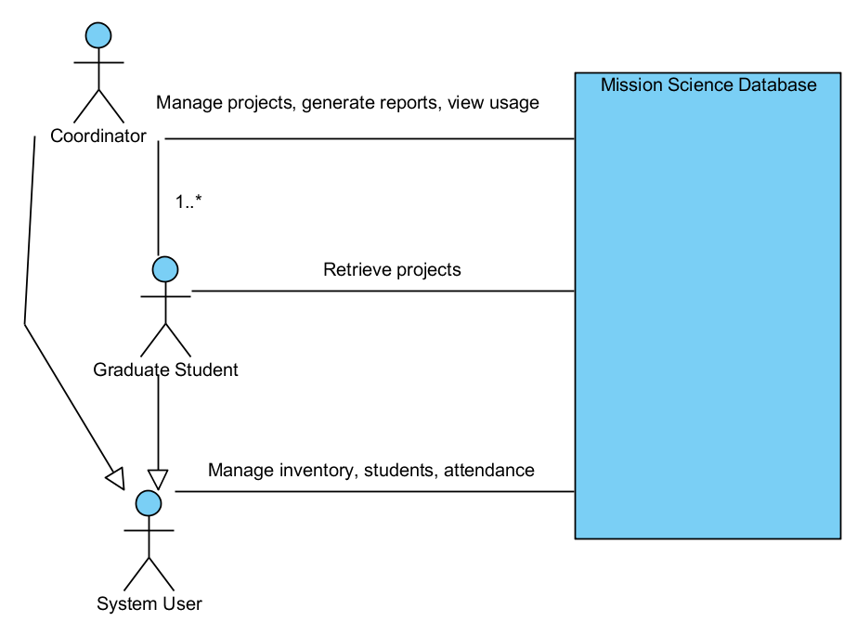
Figure 1: System Context Diagram

Table 1: Actors Summary
Actor | Description | Responsibilities
Coordinator | Manager of the database system and coordinator of Mission Science efforts | - Manage lesson plan data  - Run reports for funding opportunities  - Check logs of recent activity
Graduate Student | Viterbi/USC graduate student visits the various STEM school locations to teach the specified lesson plan(s). | - Execute lesson plans  - Collect sign-in sheets for attendance
System User | Any user can maintain inventory and aid with data entry of sign-in sheets. | - Input sign-in sheets  - Update student information  - Update inventory in database

Artifacts & Information
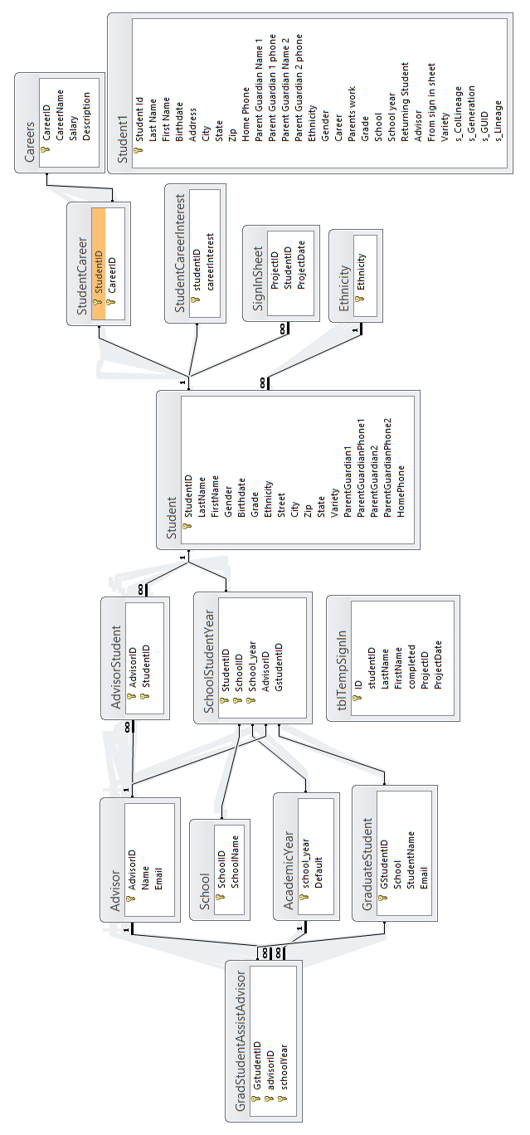
Figure 2: Artifacts and Information Diagram: Student Related
Table 2: Artifacts and Information Summary: Student Related
Artifact | Purpose
Student | The Student is the primary artifact, and is associated with the rest of the artifacts through secondary relationships.
Advisor | The advisor is the teacher at the school that is the contact point for Mission Science, to keep order during lessons.
School | The school is associated with the student, and can later be used to enhance reporting abilities.
Graduate Student | The Graduate student teaches the lessons at the school.
Academic Year | Students have information associated for each Academic Year.
Career | Career is used to track relationships between Students and Career options.
Sign-in Sheet | The Sign-in sheet is used to record attendance physically and later in the database, by recording the attendance of each student at a particular Project.

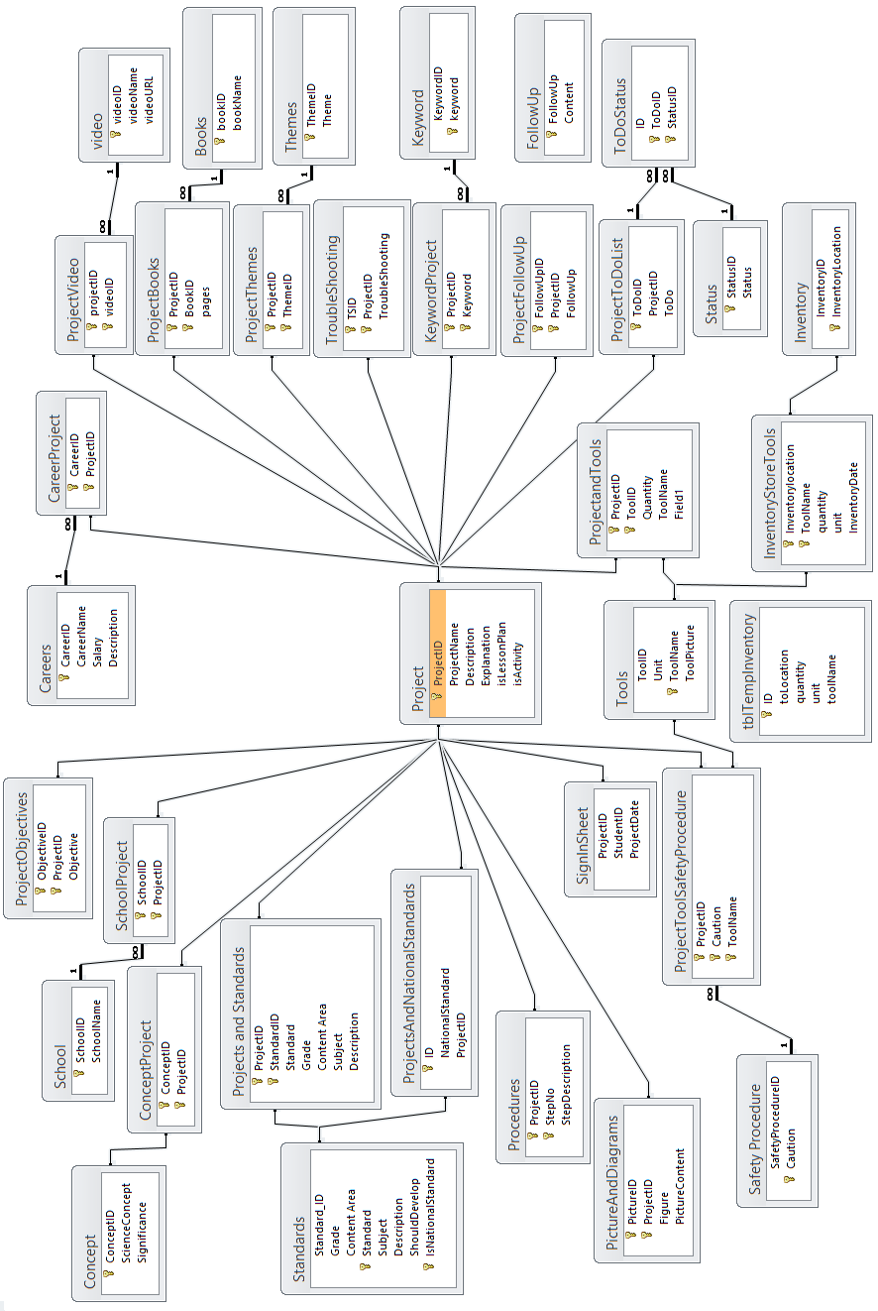
Figure 3: Artifacts and Information Diagram: Project Related
Table 3: Artifacts and Information Summary: Project Related
Artifact | Purpose
Project | Project is the primary artifact. It is associated with every other artifact in the diagram through primary and secondary relationships. A Project can be a Lesson Plan or Experiment
School | Projects are held at a school.
Objective | A Project can have a number of Objectives.
Career | A Project can be associated with a number of Careers.
Video | A Project can have informational Videos.
Book | Some Projects are simply references to content in a Book at the Center for Engineering Diversity (Mission Science).
Theme | A Project can have a number of Themes.
Troubleshooting | Troubleshooting is guidance for a Project in case there are problems.
Keyword | Enhancement to searching can allow for better Keyword searching.
Follow Up | Follow up steps to the Project.
Project To Do | To Do items associated with a Project.
Tools (Materials) | All possible tools and materials that are documented.
Inventory of Tools (Materials) | Inventory count (in various locations) of Tools and Materials.
Sign-in Sheet | Attendance of Students at a Project.
Safety Procedure | Certain Safety Procedures are associated with Tools and/or Materials.
Project Picture | Projects can have associated Pictures.
Procedure | The actual Procedure for a Project
Associated Standard | All Projects are aligned to Standards for reporting purposes, to show the value of the Mission Science program and Projects held at Schools.
Concept | Learning Concepts associated with a Project.

Behavior
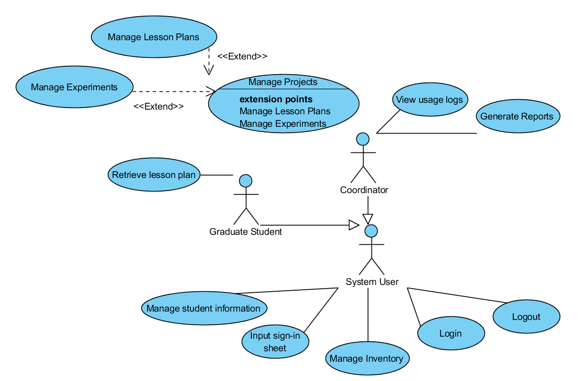
Figure 4: Process Diagram

System User Behaviors

Manage student information
Table 4: Process Description
Identifier | UC-1: Manage student information
Purpose | Add and update information about students that attend lessons
Requirements | The user has information about a student to enter in the database
Development Risks | Student information may be incomplete
Pre-conditions | A particular student is not already be in the database. The user is on the add student screen.
Post-conditions | The student will be recorded in the database.

Table 5: Typical Course of Action: No duplicate student
Seq# | Actor’s Action | System’s Response
1 | Input details about a student
2 | Click save student
3 |  | Record the student in the database.
4 |  | Show confirmation of the student is saved.
Table 6: Alternate Course of Action: similar or identical student prompts entry abort
Seq# | Actor’s Action | System’s Response
1 | Input details about a student, and the First Name, Last Name, and Birthdate are already in another record.
2 | Click save student
3 |  | Show there is a similar student in the database, with the same First Name, Last Name, and Birthdate.
4 |  | Prompt user to correct information (unique information) to be able to save the student information.
Table 7: Exceptional Course of Action: similar student exists, but not the same
Seq# | Actor’s Action | System’s Response
1 | Input details about a student
2 | Click save student
3 |  | Show there is a similar student in the database.
4 | Decide to save student information because it is a different student.
 |  | Show confirmation of the student is saved.

Input sign-in sheet
Table 8: Process Description
Identifier | UC-2: Input sign-in sheet
Purpose | Record the attendance for a particular lesson taught.
Requirements | The sign-in sheet from the lesson
Development Risks | Each student on the list should be in the database already.
Pre-conditions | All students have been entered into the database. User is on the “Input Sign-in Sheet” screen.
Post-conditions | Attendance for all students is recorded and associated with their profiles.
Table 9: Typical Course of Action
Seq# | Actor’s Action | System’s Response
1 | Input a student into a list
2 |  | Verify the student is found
… | Repeat for each student in attendance
n | Click save attendance
n+1 |  | Show attendance has been saved
Table 10: Alternate Course of Action
Seq# | Actor’s Action | System’s Response
1 | Input a student into a list
2 |  | Student is not found
3 | Input student into database
4 | Input student into the list
5 |  | Verify student is found
… | Repeat for each student in attendance
n | Click save attendance
n+1 |  | Show attendance has been saved

Manage inventory
Table 11: Process Description
Identifier | UC-3: Manage inventory
Purpose | Keep database of physical inventory up to date to reference for lesson plan requirements
Requirements | Accurate current physical count of inventory
Development Risks
Pre-conditions | User is on the “Manage Inventory” screen.
Post-conditions | The item will show the accurate count on hand.
Table 12: Typical Course of Action
Seq# | Actor’s Action | System’s Response
1 | Search for inventory item by name
2 |  | Show inventory items that match
3 | Choose inventory item
4 |  | Show information about item
5 | Change inventory quantity
6 | Click save
7 |  | Show confirmation
Table 13: Alternate Course of Action
Seq# | Actor’s Action | System’s Response
1 | Search for inventory item by name
2 |  | No items returned
3 | Click add
4 |  | Show blank page of inventory about new item
5 | Input all information and quantity
6 | Click save
7 |  | Show confirmation

Graduate Student Behaviors

Retrieve lesson plan
Table 14: Process Description
Identifier | UC-4: Retrieve lesson plan
Purpose | Graduate students should be able to view and print lesson plans to alleviate pressure on the administrator
Requirements | Lesson plans are input into system
Development Risks
Pre-conditions | There is at least one lesson plan in the system
Post-conditions | The user will be viewing the lesson plan
Table 15: Typical Course of Action
Seq# | Actor’s Action | System’s Response
1 | Search for lesson plan by subject, science standard, title, or keyword
2 |  | Show list of matching lesson plans
3 | Click on a particular lesson plan
4 |  | Show lesson plan details
Table 16: Alternate Course of Action: no matching lesson plan
Seq# | Actor’s Action | System’s Response
1 | Search for lesson plan by subject, science standard, title, or keyword
2 |  | Show no lesson plans match

Administrator Behaviors

Manage projects
Table 17: Process Description
Identifier | UC-5: Manage projects
Purpose | Create new or edit existing projects
Requirements | Have the details about a project
Development Risks
Pre-conditions | Administrator has details for the project to be entered
Post-conditions | The project is recorded in the database
Table 18: Typical Course of Action: add new project
Seq# | Actor’s Action | System’s Response
1 | Click create new project
2 |  | Show empty entry form for project
3 | Input entry form details
4 | Click save
5 |  | Show confirmation of save
Table 19: Alternate Course of Action: find a project to edit
Seq# | Actor’s Action | System’s Response
1 | Search for project by subject, science standard, title, or keyword
2 |  | Show list of matching project
3 | Click on a particular lesson plan
4 |  | Show project details
5 | Edit project details
6 | Click save
7 |  | Show confirmation of save

View usage logs
Table 20: Process Description
Identifier | View usage logs
Purpose | View brief information on what area of the database has had recent activity
Requirements | Administrator needs to view usage of the system
Development Risks | Requires ability to login and record activities as they occur
Pre-conditions | Recent activity has been logged
Post-conditions | Recent activity is displayed
Table 21: Typical Course of Action
Seq# | Actor’s Action | System’s Response
1 | Navigate to recent activity logs area
2 |  | Show recent activity logs

Generate reports
Table 22: Process Description
Identifier | UC-6: Generate reports
Purpose | Generate reports for longitudinal studies; generate reports to provide to teachers or principals to show the science standards covered; generate reports to show students that have attended but are not in the database as proper students
Requirements | Administrator has a specified data requirement to fill with a generated report.
Development Risks | Minimal: Access offers built-in reporting.
Pre-conditions | At least one report type has been saved
Post-conditions | The report desired will be viewed

Table 23: Typical Course of Action: Generate Saved Report
Seq# | Actor’s Action | System’s Response
1 | Navigate to reports area
2 | Choose a report to view
3 |  | Show desired report
Table 24: Alternate Course of Action: Generate New Report
Seq# | Actor’s Action | System’s Response
1 | Navigate to reports area
2 | Create new report, using built-in Access functionality to choose display fields, formatting, and data options.
3 |  | Display report as configured.

NDI/NCS Interoperability Analysis

Introduction
The sole NDI our project is using is Microsoft Access, with versions 2007 and 2010.

COTS / GOTS / ROTS / Open Source / NCS
Table 25: NDI Products Listing
NDI/NCS Products | Purposes
Microsoft Access 2007 | Database access
Microsoft Access 2010 | Database access

Connectors
In this project, both Microsoft Access 2007 and Microsoft Access 2010 will be using a Microsoft Access database.

Legacy System
The current system is an Access 2003 file located on a fileserver network share. It is in use by clients with Access 2007 and Access 2010. Due to constraints by Viterbi IT, it cannot currently be migrated from the Access platform.

The legacy system has considerable technical debt from lack of accurate documentation, and gradual undocumented changes to the system. It also displays some Access anti-patterns in development of forms and tables: manually binding in VBA rather than using simple, more manageable functions.

System Structure
Mission Science Database File on Viterbi IT Fileserver
Microsoft Access 2007 Client
Microsoft Access 2010 Client

Evaluation Summary
Table 26: NDI Evaluation
NDI | Usages | Comments
Microsoft Access 2007 | Database access | Older version, but still very compatible with many of the new features of Access 2010.  Less preferred option, but provides ability to upgrade legacy components that were designed for Access 2003.
Microsoft Access 2010 | Database access | More feature available, but constrained by keeping compatibility with Access 2007.  Much more preferred option due to better functionality.

